MTECH KE-4102 (ISBA) PROJECT REPORT

# NICF CYBERSECURITY INTELLIGENT NAVIGATOR

**TEAM MEMBERS**

ATHALIA HO - A0150174N

TAN CHEE WEI - A0179723U

KOK ZHENWEI, JASON - A0178372W

CHONG WAI KUAN - A0178179L

LI WEIWEI - A0056015R

LOW WAI KENT - A0178554R

MASTER OF TECHNOLOGY IN   
KNOWLEDGE ENGINEERING

BATCH KE-30(2018)

**TEAM MEMBERS**

Athalia Ho - A0150174N

Chong Wai Kuan - A0178179L

Kok Zhenwei, Jason - A0178372W

Low Wai Kent - A0178554R

Tan Chee Wei - A0179723U

MASTER OF TECHNOLOGY IN KNOWLEDGE ENGINEERING

# 1.0 EXECUTIVE SUMMARY

The National Infocomm Competency Framework (NICF) is a comprehensive resource which helps infocomm professionals and hiring executives identify the necessary competencies and skills required for a job in the ICT sector [1].

Through an expert system, we sought to improve the navigation of this framework. Singapore’s government initiatives offer a host of funding and learning opportunities to help individuals continue to upgrade their skills to remain competitive and employable.

This expert system would allow hiring professionals and jobseekers to map out a career plan that takes into consideration an aspired job role and current skillsets. Thereafter, it would recommend the necessary competency units necessary for the candidate to acquire and where they can pursue that competency unit.

# 2.0 PROBLEM DESCRIPTION

**Rising Protectionism**

Populism is rising which lead to the recent political changes in the US and Europe. The new political agenda promises the protection of jobs, industries and trade. New governments want industries and jobs to remain within their nations. Trade friction is resulting in an ever increasing volatile, uncertain, complex and ambiguous (VUCA) business environment. As businesses shift to new and drastic realities, employment will be severely stressed

**Adaptability**

If ever there a need to be flexible in adapting to a VUCA environment, this is it. Acquiring a portfolio of skills while keeping to a strategic direction is required. One such strategic direction is the globalisation of the online world. For example, to join the likes of AliPay, Amazon is in discussion with financial institutions to help launch banking accounts aimed at younger customers and those without a banking account.

**Acquiring Skills**

On the other hand, Mercer’s survey showed that Singaporeans felt they were not getting the right opportunities to learn and grow, with a third of them feeling their personal career goals were unattainable in their organizations. However, many organizations now believe that the ultimate responsibility for training and development lies not with the employer but with the individual. This is due to delayering of hierarchy which means fewer automatic promotion pathways. People who can learn new technological skills will remain more employable as their careers progress.

**Retaining Talent**

Human resource is one of the world’s most valuable commodity. Since the dawn of the industrial revolution, Karl Marx underlined that industrialization had changed the face of labor and the value of an individual. Singapore performs lower than the global average in job satisfaction. The local population has a job satisfaction percentage of 73% as reflected in a 2017 Mercer survey [2]. The global average is 82%. Only 68% of Singaporeans think that their companies are good places to work. The reason? Singaporeans displayed a low sense of pride in their work due to concerns about innovation and career development.

**2.1 PROJECT OBJECTIVE**

**Focus on Cybersecurity**

Considering the availability of a myriad of courses and related job functions, we limited our scope to the IT security sector to make the businesses more secured. The scope of our recommender system would highlight the competency gaps for an individual who aspires to develop his/her career in the field of IT security.

**Unique Selling Points**

**a. Systematic NICF Framework**

Our project, the NICF Cybersecurity Intelligent Navigator, would recommend the relevant NICF courses for an individual according to a job role in Cybersecurity and evaluate if they are ready for a job role. For example, a HR personnel intends to take the necessary steps to upgrade a candidate’s skills to promote them to a higher role. The pathfinder would allow the user to identify if a candidate has the right cybersecurity competencies for a job role according to the NICF framework.

**b. Individual Skills Gap Analysis**

To offer another scenario, an individual is already working in the IT Security sector but intends to rise the ranks as a director and would like to know what skillsets are necessary to achieve his/her goal. This system evaluates the gaps in their training knowledge and recommend the relevant competencies the candidate should acquire to be ready for the new job role.

Our recommender system provides the relevant NICF courses according to the individual’s competency so that they can make an informed decision about their career development in a realistic and practical manner.

This would be achieved through a recommender system which prompts the individual through a series of questions which assess the individual’s profile and job competencies to make the best suited recommendation of courses according to the aspired career path [3].

**c. Fast and Clear**

The advantages of using this recommender system are time-saving and forward-looking. The benefits of the system would be that the individual avoids spending time wading through a deluge of information which is available in NICF’s roadmap.

This recommender system optimizes the search process which could otherwise have been a lengthy ordeal for the individual by truncating the search through ruling out options which are irrelevant to the human resource personnel and eliminating unnecessary information which is irrelevant to the candidate’s ability.

This would improve the hiring process. The end-user would be able to evaluate if he/she should send the candidate for courses to prepare them for their next role.

**Target Customer - Company HR Department**

The human resource personnel would be the ultimate customer. The system recommends the competency required or satisfied according to the user’s assessment of a candidate’s competencies and skillsets. A career path can be mapped out for a candidate in a company. It would make a sound recommendation for how much time a candidate would need to grow into a job role.

This system would help human resource individuals manage the employees by ensuring that there are development opportunities and identifying gaps in a candidate’s skillsets.

# 3.0 KNOWLEDGE MODELING

**Decision Tree Model**

Based on the elicitation with our Subject Matter Expert (Appendix A : Knowledge Acquisition), the Decision Tree model was most suitable as it shows the alternative paths under the NICF framework for a particular decision. It is also a clear and useful way of capturing the process knowledge in order to develop the solution.

High-resolution images of the decision tree model are appended in the zip file.

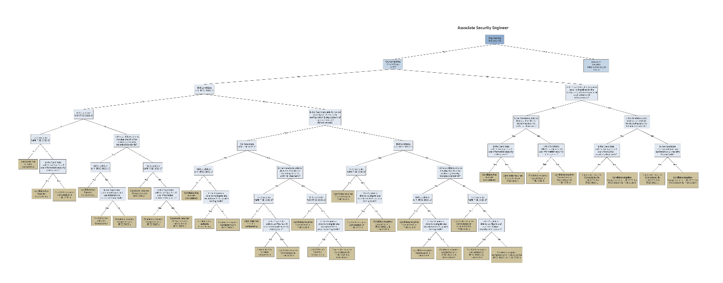

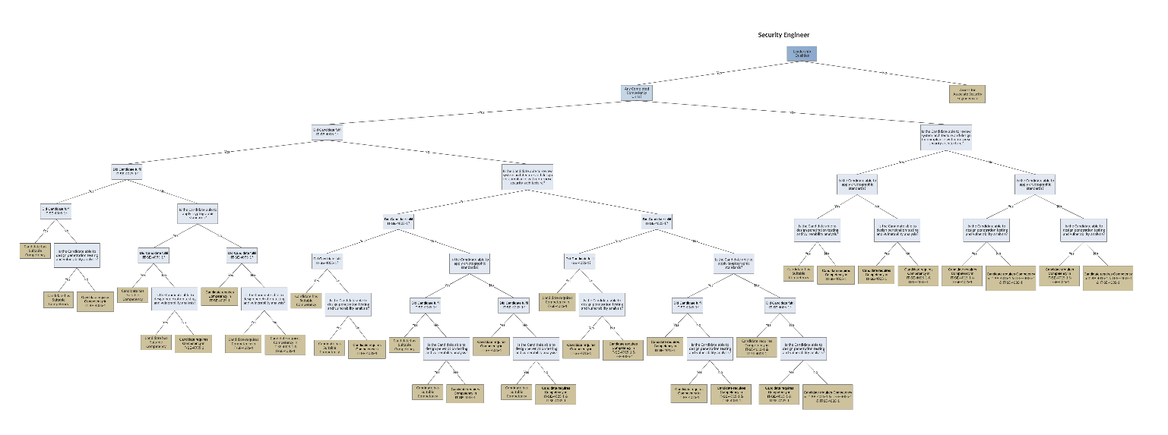

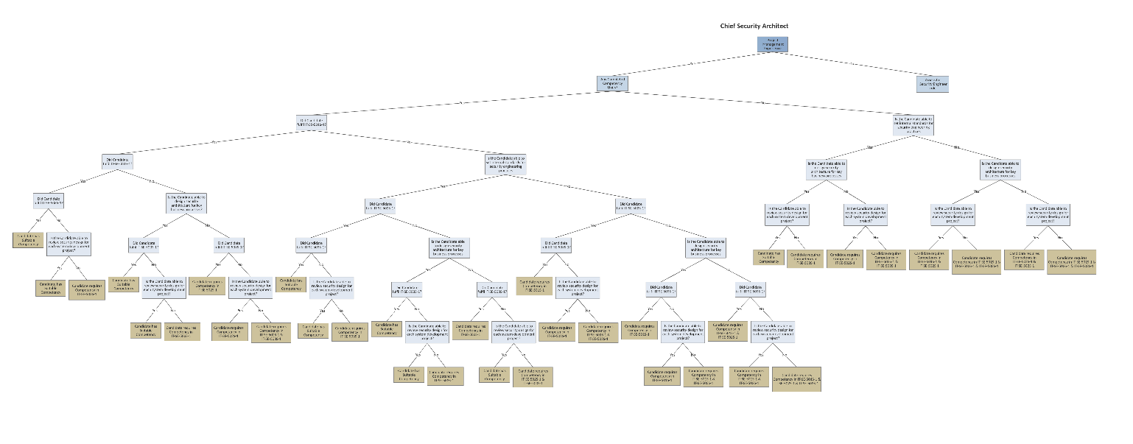

# 4.0 SOLUTION OUTLINE

**Sandboxing**

Within the NICF competency map for Cybersecurity, there are job families in Security Engineering, Security Management, Security Services and Security Operations. We have limited our scope to Security Engineering and the three job roles which were mapped out within this job family. The job roles are: Associate Security Engineer, Security Engineer and Chief Security Architect.

**Inference Structure**

The system starts by querying the user for the selection of job roles based on their inference structure as shown below. These job roles correspond to its respective competencies in their Decision Tree in the previous section.

*Figure 1: Inference Structure Diagram for Associate Security Engineer Job Role*

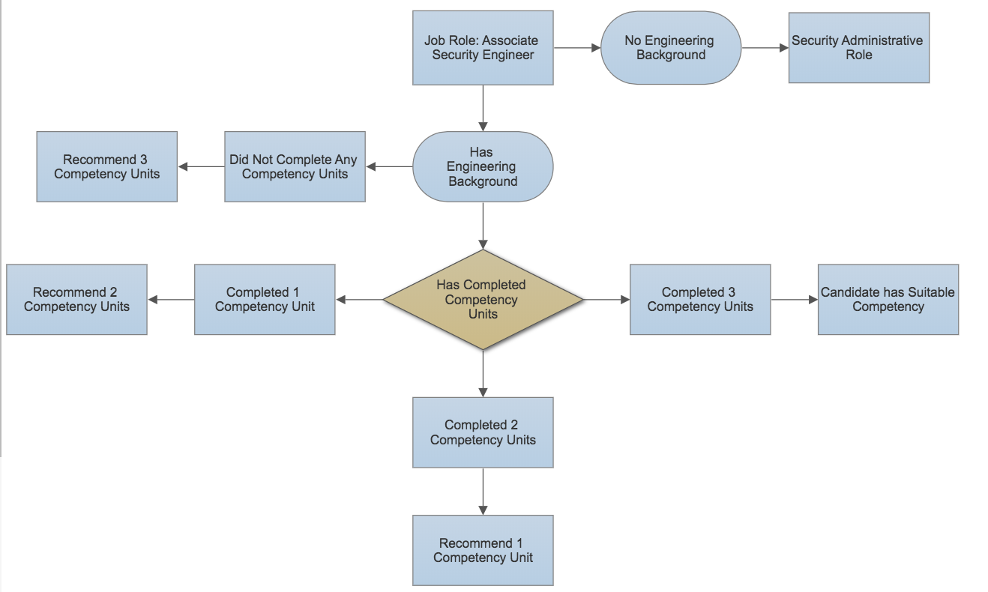

*Figure 2: Inference Structure Diagram for Security Engineer Job Role*

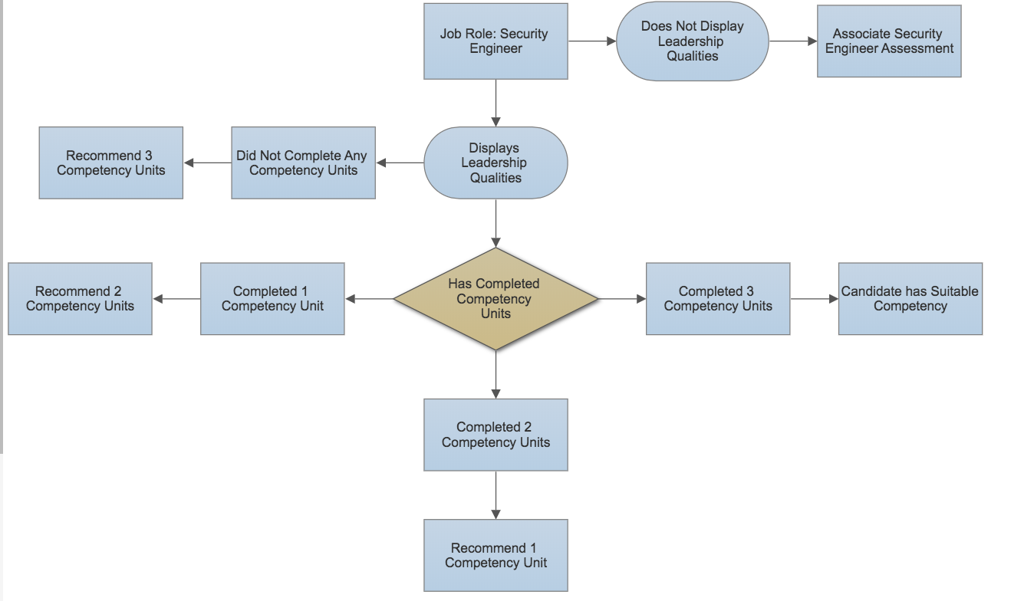

*Figure 3: Inference Structure Diagram for Chief Security Architect Job Role*

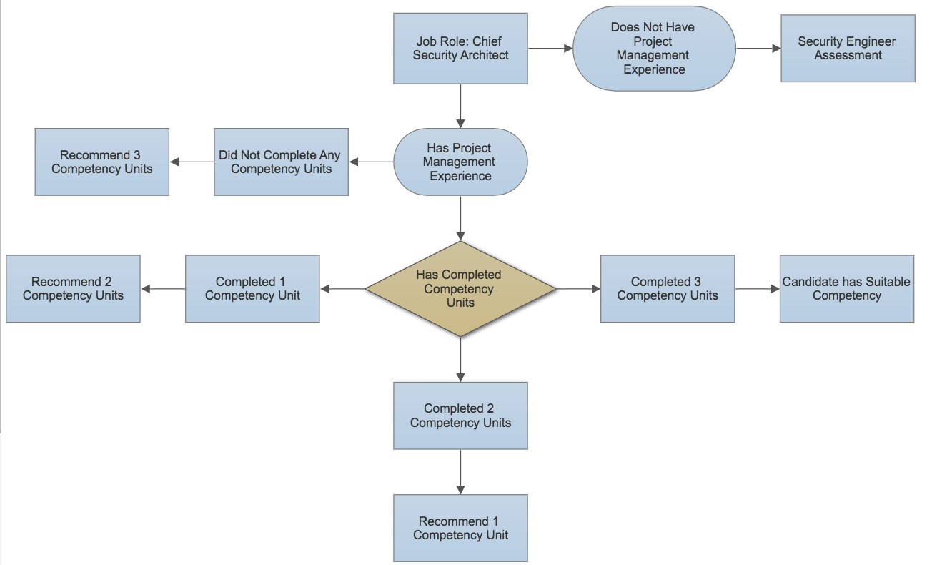

**“Rete” Rule-based Algorithm**

We used a decision tree model in our expert system which applies the Rete algorithm of rule-based pattern matching [4]. The final output of the system are the competency codes, description of the competency required and the institute providing the competency courses (if available).

**Readiness level for job role**

The significant features of our system would be the formulation of the certainty factor which takes the candidate’s experience into consideration. This would give a better accuracy in evaluating the candidate’s competency because it is able to intelligently factor different considerations to determine a candidate’s readiness for a job role [5].

We have assumed that the user is only using the system to evaluate a role within Security Engineering in Cybersecurity. We have also built our system around the NICF framework based on the assumption that it is the most comprehensive roadmap available.

Another assumption we have made based on our knowledge acquisition is that the competency courses do not have hard prerequisites such as education background. We have also eliminated other considerations an individual would take into consideration when selecting a job role such as salary range and career progression.

**Certainty Factors (Readiness)**

We also made assumptions based on our knowledge acquisition interview with our subject matter expert and examining online job description based on a similar position. We have identified his expertise as a legitimate knowledge source to build the system on. With his assistance, we mapped out the following certainty factor model, in a scale of relative importance of multiple scale factors, and implemented in our expert system.

|  |  |  |
| --- | --- | --- |
| Class |  | Certainty Factor |
| CompetencyUnit1 | (IT-SE-301S-1) Review security baselines in the configuration & deployment of applications and infrastructure | 0.2 |
| (IT-SE-401S-1) Review system architecture and design for compliance with enterprise security architecture |
| (IT-SE-501S-1) Set internal standards for security engineering practices |
| CompetencyUnit2 | (IT-SE-302S-1) Develop checklist for reviewing security technical standards | 0.5 |
| (IT-SE-402S-1) Apply cryptographic standards |
| (IT-SE-502S-1) Design security architecture for key business processes |
| CompetencyUnit3 | (IT-SE-303S-1) Configure and use information security testing tools | 0.7 |
| (IT-SE-403S-1) Design penetration testing and vulnerability analysis |
| (IT-SE-503S-1) Review security design for each system development project |
| Skill1 | review security baselines | 0.15 |
| review system architecture and design |
| set internal standards for security engineering practices |
| establish information security policies, standards and procedures |
| Skill2 | develop checklist for reviewing security technical standards | 0.35 |
| able to apply cryptographic standards |
| design security architecture for key business processes |
| manage the budget and capital/ operating expenditure |
| Skill3 | configure and use information security testing tools | 0.4 |
| design penetration testing and vulnerability analysis |
| review security design for each system development project |
| review, endorse and align information security and information risk management strategy with business strategy |
| Skill4 | possess a broad range of technical skills including networking, operating systems, applications, firewalls and security technologies | 0.55 |
| have at least 3 years’ experience relevant to security solution/implementation |
| have good knowledge of enterprise scale security architectures which may include TOGAF or SABSA? |
| good knowledge in leadership for the company within the information security sphere |
| Skill5 | possess at least 1 to 2 years of security engineering experience? | 0.65 |
| have good knowledge of industry standards? |
| certified as a CISA or CISSP or CISM? |
| able to obtain executive support for information security and is responsible for overall information security risk? |
| Skill6 | possess a degree in Computer Science/IT or equivalent? | 0.3 |
| possess a degree in Computer Science, Information Systems, Engineering or equivalent? |

**Limitation of the current solution**

The limitation of our system is that it only takes in user input from several options provided by the system. It is not intelligent enough to function as a chatbot.

In deriving the Certainty Factors for our system, the value of relative importance under various factors are assigned based on the opinion and sensing from the Subject Matter Expert. The sample size was limited due to the time constraints of the project. It may lead to a more accurate or representative result against the industry if we are able to conduct a survey to various HR departments within the cyber security industry.

# 5.0 CONCLUSION & REFERENCES

In the process of acquiring knowledge and representing the knowledge into an inference diagram, our team had encountered representational issues which are inherent to knowledge engineering.

There was the tedium of representing a large knowledge base that was acquired from our domain expert which required the application of logic and analysis to best represent it. We learnt that every documentation was a necessary process in building an expert system, such as crafting the inference structure diagram and a knowledge graph.

This informed the foundation on which our expert system was built and it was crucial in structuring the way the code was written.

Our team also learnt how to execute parallel-programming as a team, where tasks were delegated to different members of the team according to our roles such as coding and UI programming to complete the expert system in a timely manner. We applied AGILE methods to build our program as well as manage the resources of the team. This taught us how to deal with constant changes and improvements as a team while we built the expert system.

As much as we have tried to incorporate sophisticated logic recommendation in our system, we completed this first version as a proof of concept. In the next iteration, we would like to take the opportunity to further enhance the system’s ability to predict a candidate’s competency with added variables such as personality, aptitudes, achievements and education which require more knowledge engineering of the system.

***

[1] National Infocomm Competency Framework (NICF). (2018).   Retrieved from <https://www.imda.gov.sg/nicf>

[2] Williams, A. (2017). A Third of Singaporeans are Unhappy at Work. *The Straits Times*. Retrieved from <http://www.tnp.sg/news/business/third-singaporeans-are-unhappy-work>

[3] Peter Norvig, S. R. (1994). *Artificial Intelligence: A Modern Approach*: Pearson.

[4] Rete Algorithm. (19 Sept 2017).   Retrieved from <https://en.wikipedia.org/wiki/Rete_algorithm>

[5] Al-Badarenah, A. (2016). An Automated Recommender System for Course Selection. *International Journal of Advanced Computer Science and Applications, 7*(3).

Samy S. Abu Naser, & Ola, A. Z. A. (2008). An Expert Sytem for Diagnosing Eye Diseases Using CLIPS. *Journal of Theoretical and Applied Information Technology*.

Joonseok Lee, K. L., Jennifer G. Kim. (2013). Personalised Academic Research Paper: Recommendation System.

# APPENDIX A: SAMPLE INPUT & SYSTEM OUTPUT

Use Case #1: HR personnel assessing a candidate for promotion

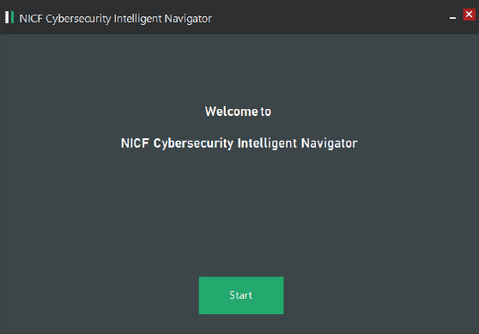A candidate in the organization is a likely candidate for promotion. He/she has taken a few competency units but missed out on one unit. The system will identify the gap and recommend the competency unit for the candidate.

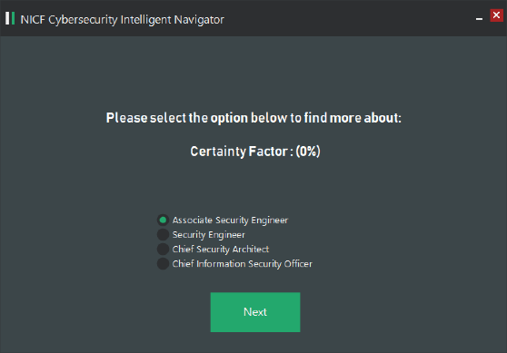



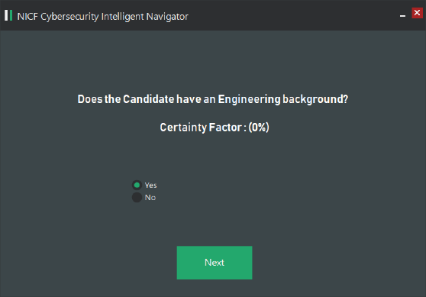

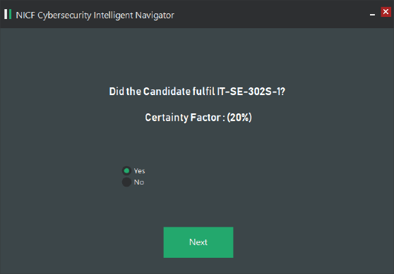 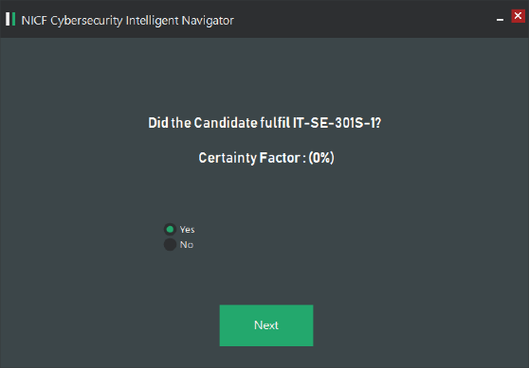

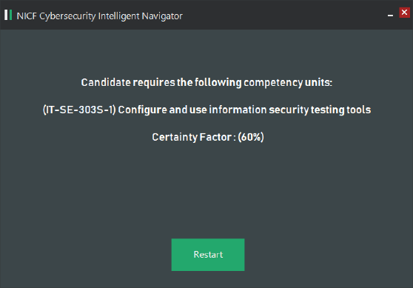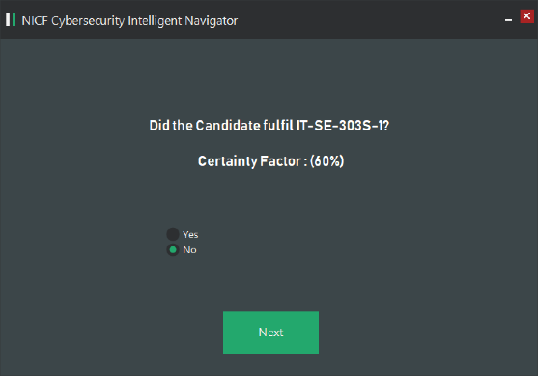

Use Case #2: Candidate intends to take on management role and needs to know required competencies

A candidate has been working for a few years and has acquired some experience. He/she would like to assess if they are competent for a role as Chief Security Architect. The system will evaluate his/her experience sand recommend the relevant competency unit to bridge knowledge gaps.

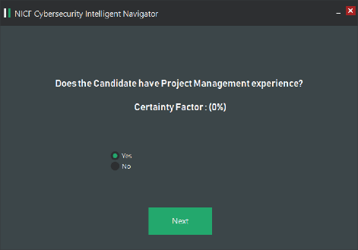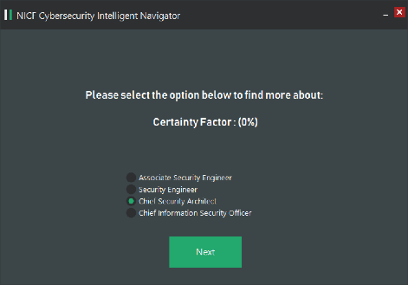

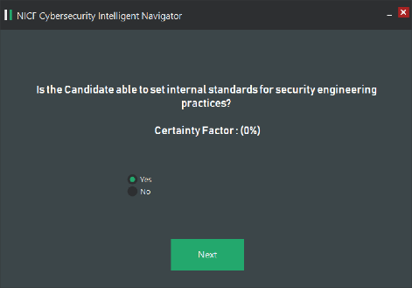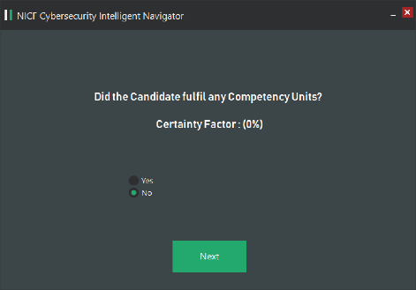

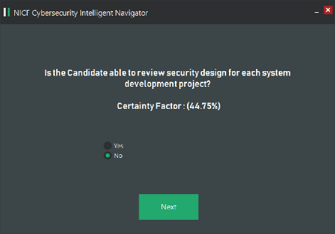 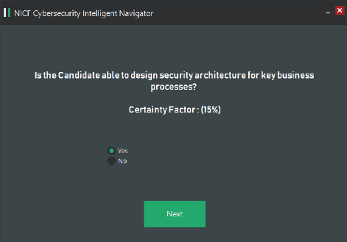

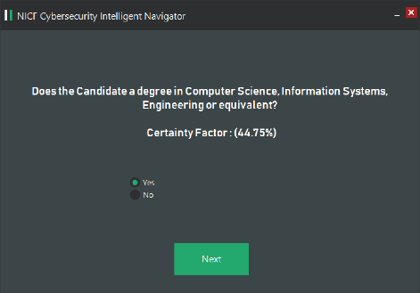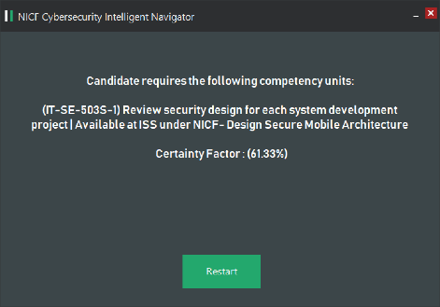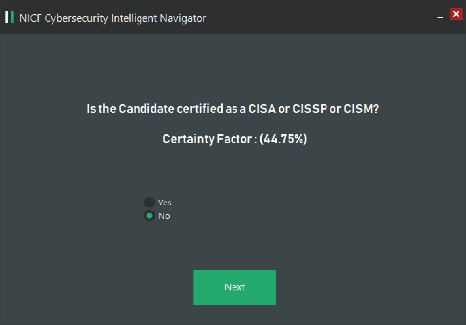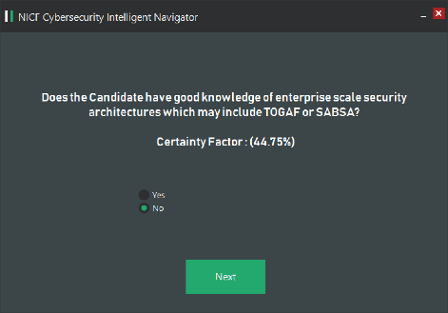 Use Case #3: Candidate has not completed any courses but has job experience

The candidate has not taken any competency units to prepare him/her for the job role. However, this candidate has accumulated experience from his/her previous role. The system will evaluate certain skills pertaining to the job role and evaluate the candidate’s readiness for the aspired job role.

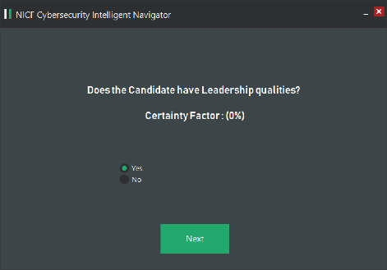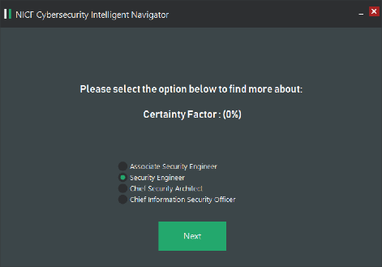

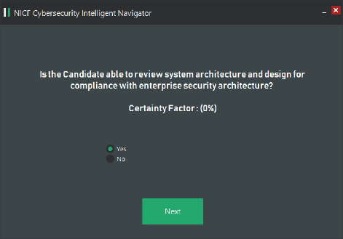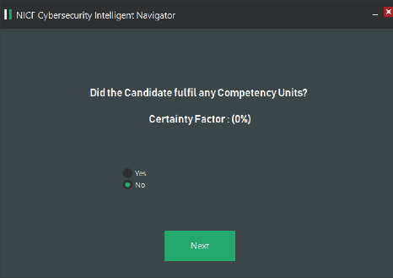

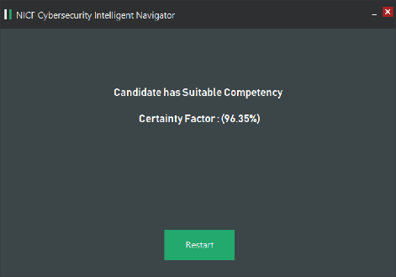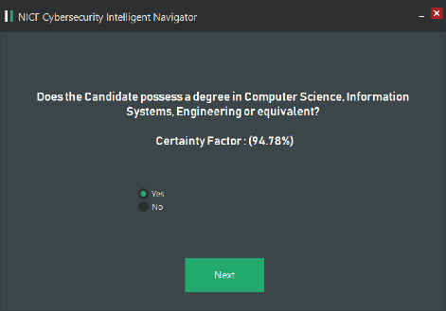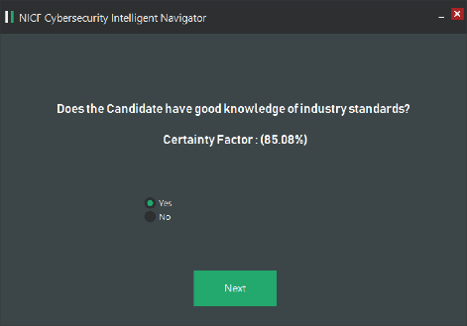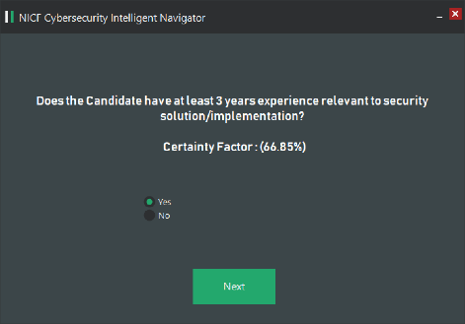 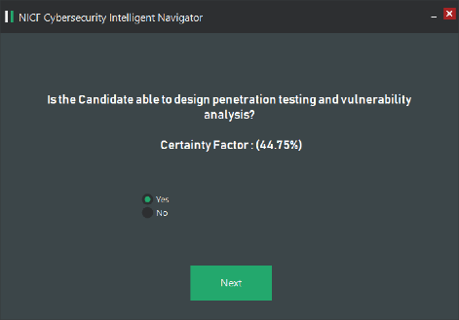 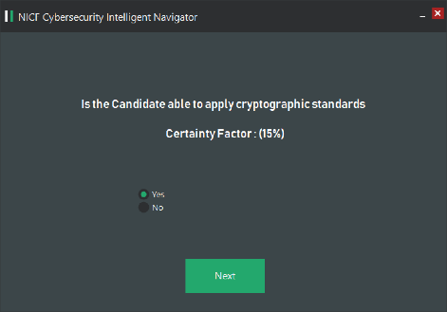

# APPENDIX A: KNOWLEDGE ACQUISITION

This was an interview conducted on 6th February 2018 with Mr Tan Liong Choon, Senior Lecturer & Consultant at the Institute of System Science at National University of Singapore. He was Deputy Director of the National Infocomm Competency Academy in 2007, to help spearhead the development and implementation of competency-based training in various Institute of Higher Learning in collaboration with WDA & IDA. He also helped set up an IT competency framework based on the NICF (National Infocomm Competency Framework).

1. Are there prerequisites to taking an NICF course?

Ans: Pre-requisite is course-dependent. There is no pre-requisite specific to NICF itself e.g. ITIL® Service Strategy course requires participants to have already obtained the ITIL Foundation cert.

1. What are the tangible benefits to the candidate using the NICF framework?

Ans: NICF is a strategic initiative.

1. What is the likelihood that a candidate can achieve the career he wants through certified learning?

Ans: Too subjective. The competitive advantage is that you will meet the first HR hurdle, the job pre-requisite criteria if certification is stated as a MUST have. Once cleared the first HR filter, you will also have the advantage of a greater chance of landing a job with the cert than another applicant without one, if all else being equal. Certification serve as a recognition and validation of your knowledge and skills. Additional proof e.g. experience, domain-fit and other related skills (e.g. interpersonal skills) will have to be considered.

1. Is there a success rate that you can provide for employment in the aspired role?

Ans: NICF was a strategic initiative to support Continuous education for adult workers. ISS is just one of many providers. For employment / job placement stats, it will have to come from SSG (formerly WDA), provided they have system to track and capture them.

1. How successful is the current framework?

Ans: Note that the framework has been replaced as of 2017 though with various elements of the original NICF still intact. As a strategic and masterplan initiative, I would consider it a major success.

* It helped draw attention to and put organization capability development on the minds of industry senior management.
* It spearheaded the effort by all the IHL in looking at competency-based learning courses and rethink assessment from the competency-based angle. (supply-side of adult learning)
* It provided the needed boost for companies to send staff on training and skills development. (demand-side)
* It draws national attention to companies on the need for a more structured and systematic approach to competency development e.g. establishing a competency framework for the company in HR best practice.
* Tangible impact-wise, it was highly successful in terms of output – i.e. number of courses accredited, number of workers trained and number of SOA (Statement of Attainment) awarded.

1. What would you say would be helpful improvements on the current framework?

Ans: the CU currently does not have sub-tier/grade. i.e. a Project manager may need a basic understanding of cybersecurity but not in-depth. Currently CU is defined on absolute terms. Also consider practicum element. In addition, the number of CU and variations of it could be more dynamic as the workplace is constantly changing. The domain specific aspect is also lacking (too generic)

1. What functions in a recommender system would be beneficial for an agency like NICF?

Ans: NICF is not an agency. What is meant by “Recommender system”? If you are referring to CET i.e. training providers, then, some form of portfolio perceptive of jobs would be useful. E.g. a project manager is not solely project management, he may need other skill range e.g. interpersonal skill, problem solving skill, presentation skill etc.

1. What types of candidates look for NICF courses?

Ans: adult workers (both employed and in-between jobs)

1. What are common pain points for NICF administrators?

Ans: support infrastructure. e.g. more advanced technology-aided ways to keep records (attendance, feedback, assessment etc.)

1. What are common pain points for NICF course applicants?

Ans: Understanding NICF and how to plan and assess their training needs

1. Would you encourage an individual to take up more than one course?

Ans: Yes. The world is not organized in terms of skill topics but a portfolio of skills sets in a portfolio of jobs functions and secondary functions.

1. Would you discourage an individual to take up more than a number of courses?

Ans: No.

1. Would you be able to assign a probability factor to the skill being relevant to the aspired job role?

Ans: No. not meaningful. Too subjective and dynamic.

1. How did NICF come up with the framework?

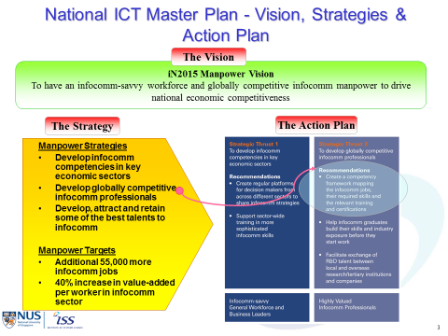

1. Are there any KPIs for the framework?

Ans: Yes. WDA maintain various KPI. Most common is Number of people trained (seats) and number of SOA awarded. Others include customer feedback on ability to apply training/skill learned to job and given greater responsibility or job expansion due to expanded skills/new skills acquired.

1. How does the framework compare against other international standards?

Ans: No many such framework. It is modelled after the Australia’s AQF I guess.

1. How does the NICF courses compare against MOOC courses?

Ans: not appropriate to compare them. MOOC is a delivery method. NICF is a competency definition framework

References:

[1] Infocomm Media Development Authority 2015 Masterplan. (2018).   Retrieved from <https://www.imda.gov.sg/infocomm-and-media-news/buzz-central/2006/9/in2015-masterplan-offers-a-digital-future-for-everyone>

# APPENDIX B: USERS MANUAL

**USER’S MANUAL**

*NICF Cybersecurity Intelligent Navigator*

Prepared by:

Athalia Ho - A0150174N

Chong Wai Kuan - A0178179L

Kok Zhenwei, Jason - A0178372W

Low Wai Kent - A0178554R

Tan Chee Wei - A0179723U

Mar, 2018

**Revision Sheet**

|  |  |  |
| --- | --- | --- |
| **Release No.** | **Date** | **Revision Description** |
| Rev. 0 | 6/Mar/18 | User’s Manual Created |
|  |  |  |
|  |  |  |
|  |  |  |

**USER'S MANUAL**

**TABLE OF CONTENTS**

Page #

**1.0** **GENERAL INFORMATION 1**

**1.1** **System Overview 1**

**1.2** **Acronyms and Abbreviations 1**

**2.0** **EULA 1**

**3.0** **GETTING STARTED 1**

**3.1** **Setting up NICF Cybersecurity Intelligent Navigator 1**

**4.0** **USING the CLIENT APPLICATION 2**

**4.1 Functions in the program 2**

**4.2 Walkthrough of the program 2**

# GENERAL INFORMATION

## 1.1 System Overview

The NICF Cybersecurity Intelligent Navigator system would allow hiring professionals and jobseekers to map out a career plan that takes into consideration an aspired job role and current skillsets. Thereafter, it would recommend the necessary competency units necessary for the candidate to acquire and where they can pursue that competency unit.

## 1.2 Acronyms and Abbreviations

NICF – National Infocomm Competency Framework

# eula

Please read this End-User License Agreement ("Agreement") carefully before clicking the "I Agree" button, downloading or using NICF Cybersecurity Intelligent Navigator ("Application").

By downloading or using the Application, you are agreeing to be bound by the terms and conditions of this Agreement.

If you do not agree to the terms of this Agreement, do not download or use the Application.

**License**

NUS ISS KE30 - NICF Cybersecurity Intelligent Navigator Team grants you a revocable, non-exclusive, non-transferable, limited license to download, install and use the Application solely for your personal, non-commercial purposes strictly in accordance with the terms of this Agreement.

**Restrictions**

You agree not to, and you will not permit others to:

a) license, sell, rent, lease, assign, distribute, transmit, host, outsource, disclose or otherwise commercially exploit the Application or make the Application available to any third party.

**Modifications to Application**

NUS ISS KE30 - NICF Cybersecurity Intelligent Navigator Team reserves the right to modify, suspend or discontinue, temporarily or permanently, the Application or any service to which it connects, with or without notice and without liability to you.

**Term and Termination**

This Agreement shall remain in effect until terminated by you or NUS ISS KE30 - NICF Cybersecurity Intelligent Navigator Team.

NUS ISS KE30 - NICF Cybersecurity Intelligent Navigator Team may, in its sole discretion, at any time and for any or no reason, suspend or terminate this Agreement with or without prior notice.

This Agreement will terminate immediately, without prior notice from NUS ISS KE30 - NICF Cybersecurity Intelligent Navigator Team, in the event that you fail to comply with any provision of this Agreement. You may also terminate this Agreement by deleting the Application and all copies thereof from your mobile device or from your desktop.

Upon termination of this Agreement, you shall cease all use of the Application and delete all copies of the Application from your mobile device or from your desktop.

**Severability**

If any provision of this Agreement is held to be unenforceable or invalid, such provision will be changed and interpreted to accomplish the objectives of such provision to the greatest extent possible under applicable law and the remaining provisions will continue in full force and effect.

**Contact Information**

If you have any questions about this Agreement, please contact us.

# GETTING STARTED

## 3.1 Setting up NICF Cybersecurity Intelligent Navigator

1. Unzip Debug 4.1v.zip into local folder

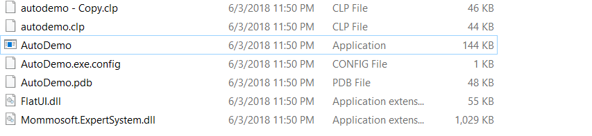

1. Run “AutoDemo.exe” and you will be lead to the main screen below.

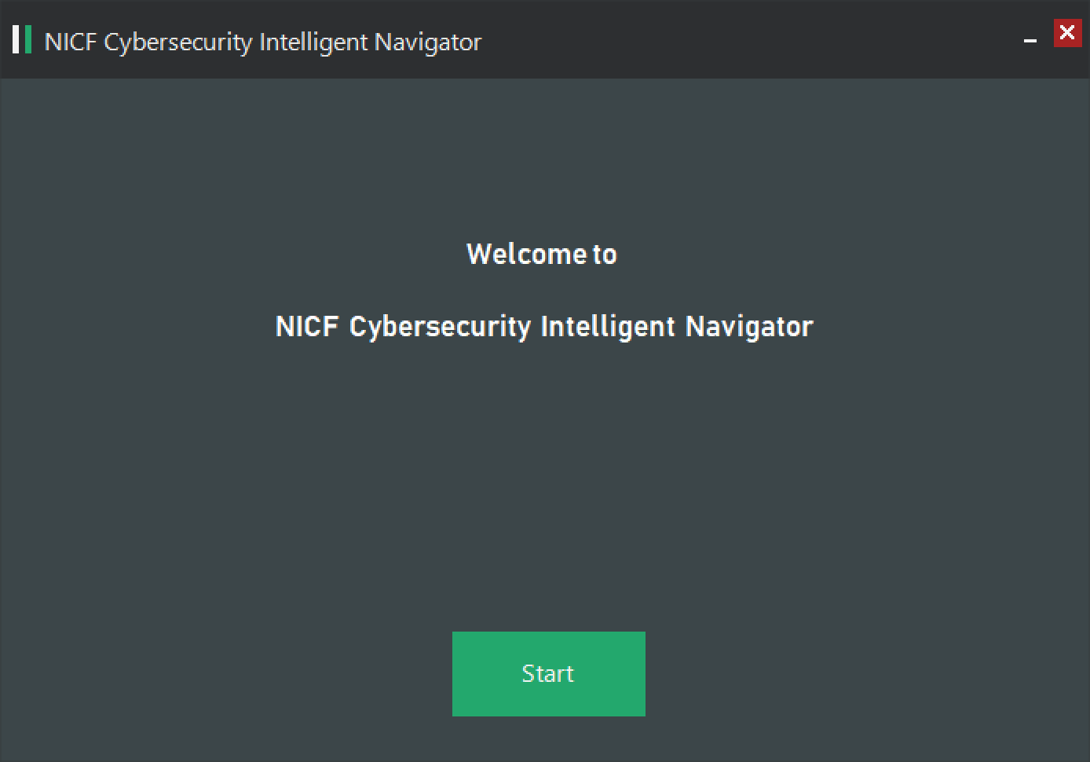

1. Click “Start” to proceed with the navigation of the NICF Cybersecurity Intelligent Navigator

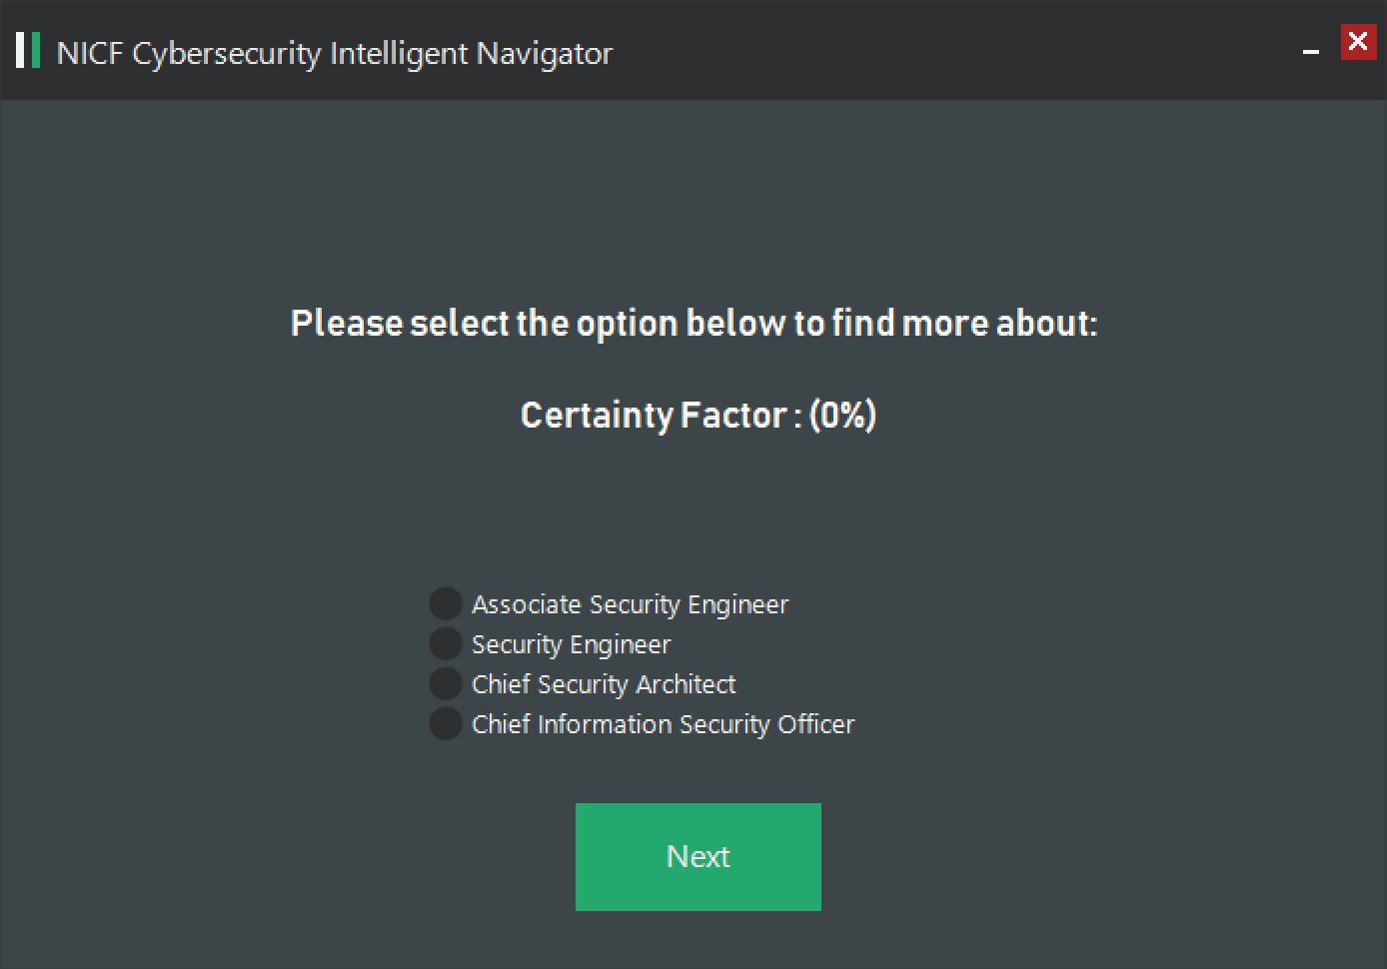

# USING the CLIENT APPLICATION

## 4.1 Functions in the program



To proceed to next page

To terminate the program

## 4.2 Walkthrough of the program

1. Selection of cyber security related roles

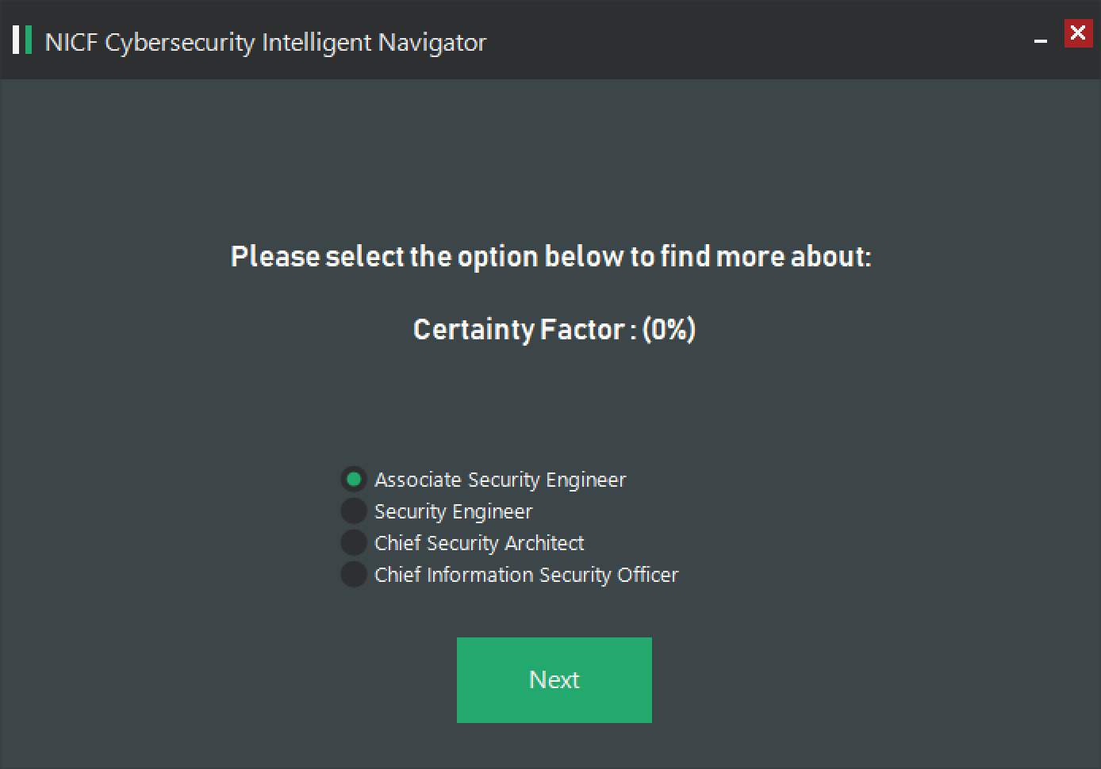

1. Selection of qualities candidates possess

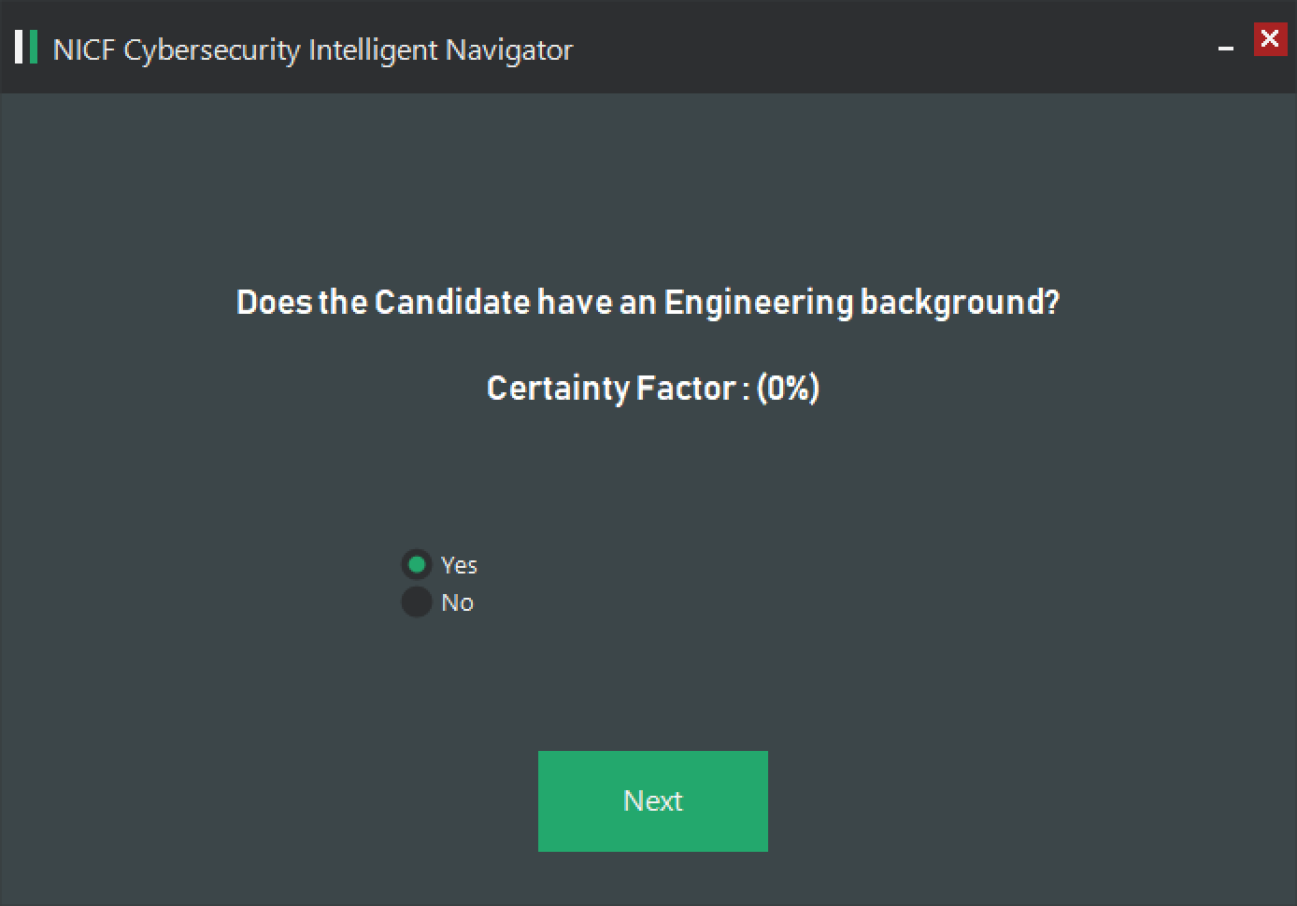

1. Understand whether candidate have fulfilled competency units that is suitable for the role selected.

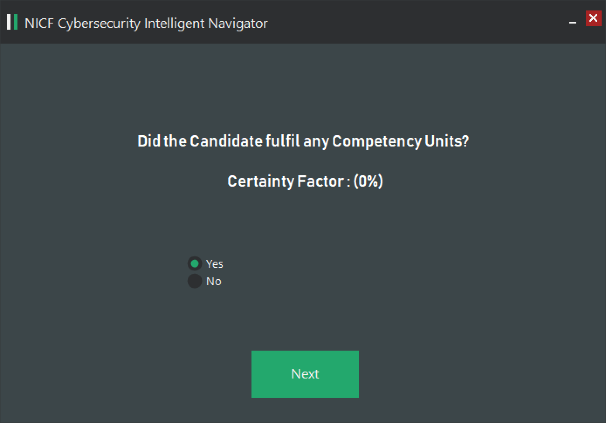

1. Getting more information on details of fulfilment of competency units

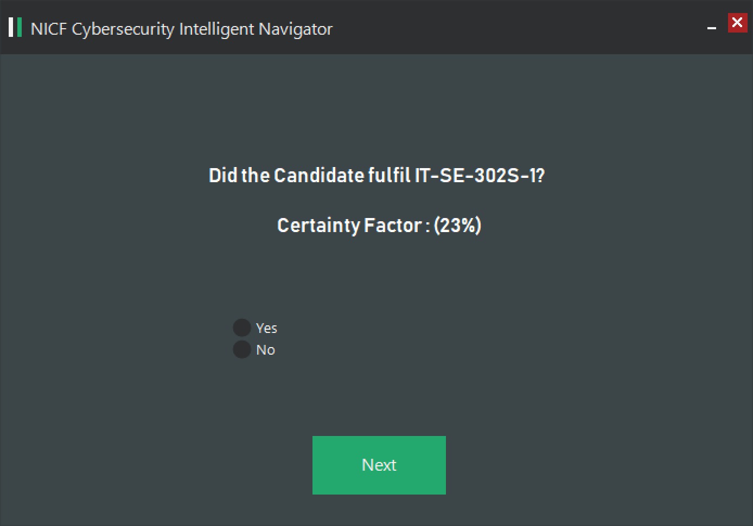

1. Display of results after all the inputs are entered.

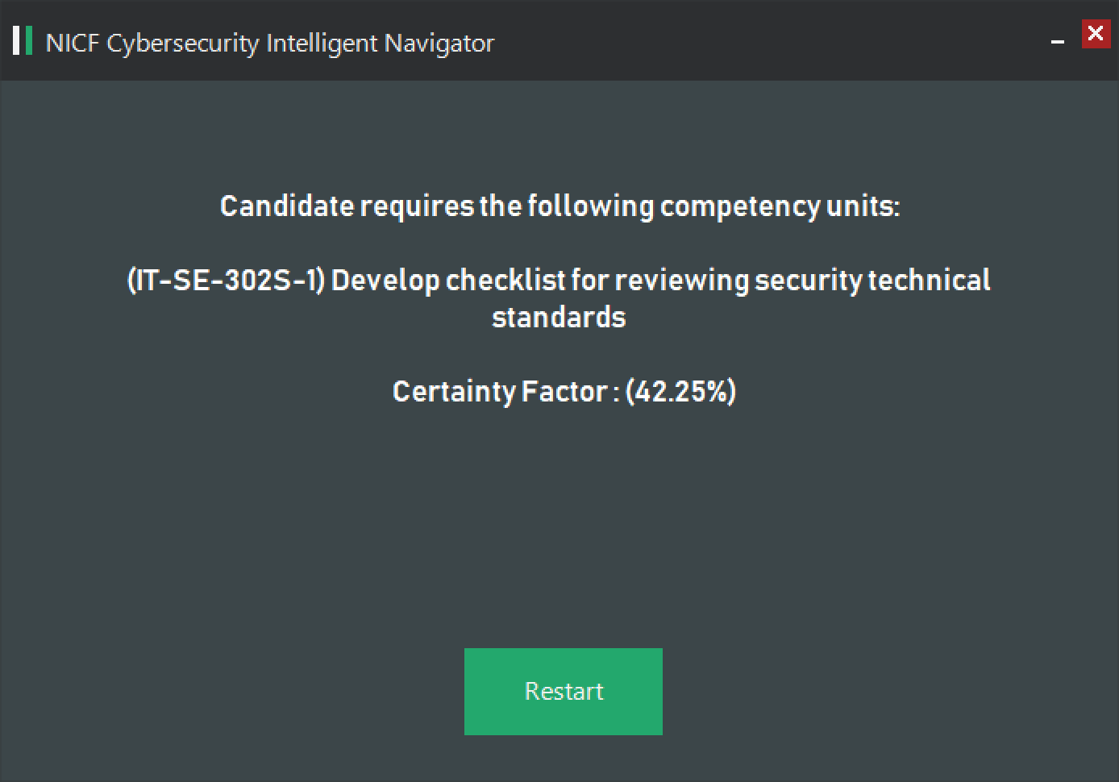

The results page will display and notify users on the relevant competency unit the candidate is supposed to obtained and recommend the training institution the candidate can sign up the course with.